|  |  |
| --- | --- |
| Kernel7 | Kernel 7 is the file that brings together functions from all the files and execute them |
| GPIO | This file is the file used to send commands to the led light. GPIO.asm brings the FLASH function on the stack and removes it from the stack after 24 flashes are executed. |
| Timer | This file acts as a dumb timer to have pauses between the flashes |
| Factorial | This file turns the led flashing into a factorial function, in this case it being 4 and the led flashes 24 times. His file brings r1 to 1 and pop it off after that. |

2. r1 holds the value of the program, in this case the value is 4 which will be used in factorial file to work out the number of flashes before the stack is popped out.

**KERNEL7**

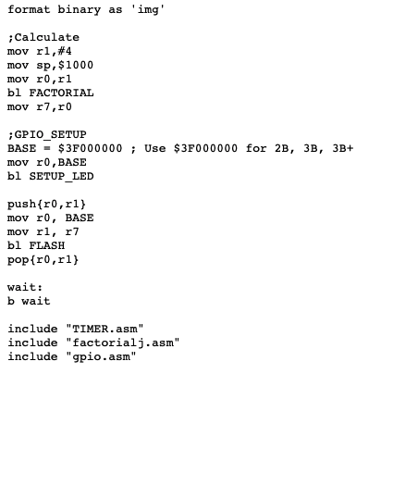

**GPIO**

